Business Requirements Sheet for SUTRA

#Business Identity, Context, Stage of Business, Stage of Client (Who we are making/customizing Sutra for in beginning), Business Process of Client and Overall Project Requirement:

We are making Sutra, an enterprise grade picture-first ERP (enterprise resource planning software) built to handle over 500 users and different departments per firm at once, and over 20 firms and/or branch locations at once for a single client; with our roadmap in future being multiple clients. Sutra lets clients connect/migrate-from/deeply integrate with apis - their existing accounting/compliance tools like busy erp or tally erp - for accounting maintenance and year round compliance reporting options. We are meant to be a Textile Business’es - or more specifically for the first enterprise project on hand, an indian ethnic designer/manufacturer/wholesaler who has 4 different firms) - end to end tool solution for/from supply chain mgt, production management, sale and cataloguing management (with a dedicated customer side storefront), dispatch management, reporting hub, design-with-ai-using-business’es-own-products-and-materials hub with a dedicated designer agent, to channel-allocation/branch/multi-location warehousing and data management, etc. All the while, relevant money accounting entries from each module are taken through dedicated forms and pushed into busy (sometimes automated like invoicing, but manual form like purchase inward). We hold a lot more data about the same masters or activities that are shown/pushed in busy. For example we calculate a product’s demand graph score or a customer’s payment score or a sale order’s urgency or notes, but only push relevant accounting entries into busy erp and reconcile our money/accounting source of truth with it, with conflicts being escalated, and considering busy’s calculation as the actual source of truth for money based conflict recognition. We also let the users do activities like sorting etc or make decisions by making these extra infos calculated, stored, updated and visible with our ui/ux philosophy of “right information in the right form/way at the right place for the right user, for better decision making and activity across the board”.

Our first client is Shree Radha Studio(SRS), the owner of which, operates 6 completely separate firms (besides SRS - Radhika Collection, Radhya Couture, Raaslila, SRB, RCB) with their own GST licenses, busy erp licenses and databases, and accounting; but they share operational and supply chain resources between them. For example, production of a category in SRS for Radhika, sold to Radhika in terms of accounting, and received from production directly by Radhika from SRS’s Karigars. Or for instance, SRS marking some stock of selected designs as reserved or sharing media packets or sending signals of stock-out for the selected designs for Raaslila (the online e-commerce brand in the group). They need a single control center where they can put all departments with all users in all firms on the same tool (we’ll customize some frontend for each firm later) and the same database for cross dept and cross firm communication and operation. The different firms and their users need to have completely separate logins and permissions with one’s data completely protected and isolated from other’s data entirely, except for cross channel interchanges, which are visible and manageable in the “Channels Hub” (explained below).
Sutra is a picture-first ERP with webviews and phone apps (both ios and android), where most screens/modules/apps (like cart/dispatch/production) have grid views or catalogue views with images shown with each product/material number reference that have to load extremely fast; because all skus, most supply chain materials on the floor, are all recognized and referred primarily by photos rather than the design number.

The firms should be able to source material (Generate purchase order - whatsapp linked with picture capture + take an entry of purchase inward + initiate a purchase return (with an automated credit note). Then they should be able to see the material stock in the material warehouse. Then they should be able to set consumption recipes/processes for each design’s 1 unit of production (using current materials or wips), and then make production orders for bulk production, starting with one process and karigar, out of 4 or 5 processes. They should be able to view the whole lifecycle and job cards pending after a production order is approved, even if the job has not been assigned a karigar/jobber or if any issue/receive has not been conducted within the order (since that is useful, and “delay-in-production-belt” information too). They should be able to set jobbers and per pc cost per process, for production orders per design, and then freely partly issue or partly receive against that “pending” job, where all items to be consumed per process and per color are defined with quantities, when setting BOM (Bill of Materials) and Process in the Product Master or Production Module’s Process Setting Screen. At any point, there are almost 200 production orders in active status (meaning they are at some point in the processes set for them, and Finished Good for that Prod. Order has not been received fully yet), so we need a lot of filtering and sorting views for the job cards page to bring up the ones that should be catered to on priority “that day”. Some jobs would be closed (meaning fully received as planned), some would be “unassigned” (production order approved but no karigar assigned yet), some would be “Delayed” (meaning crossed due date without expected receive backs). The production process would have 4-5 processes per design with free-flowing part-issues and part-receives each, and the last “Final” process (as marked in the Process Setting) is always received in the Finished Goods Warehouse (Dispatch Module) of either that firm, or any other firm for which that production is marked. The karigar’s are paid 30 days after their payment gets due, and their payment gets due (for the amount of cost per pc for that job) only and uptill the pcs submitted back to us /received back by us. For instance, if in a production order of 100 a job is assigned to a particular karigar, and the karigar submits only 10 pcs today. His payment will get due for 10 pcs today, and paid in a time span of 30 days. The firms also sometimes buy direct “readymade” designs from some karigars, in which case a production order is made in production module, and only in this case (which would be recognized by a dedicated process master in the process setting module called “Ready Production”), the firm “officially-on-paper” sells the materials required for production (in terms of accounting) and generates an invoice against those karigars for that material, tracks it like any production plan afterwards till receive happens. Same like any other karigar, these karigar’s payments are also made due when they submit a pc, calculated pc wise. The firms also have to have a costing module within production module where all new designs are “Priced” and approved. Costs per product in production is shown as it accumulates (with breakup) in different materials’ purchase rate avgs, consumption, and job rates set in its production lifecycle per unit; and for completed productions (in this case completed means the job/ job rate for last process in a production has been set, the costing should be marked as “complete” with a pre-set gross margin %age. This costing should be sent for approval to the production manager and admin (either’s approval works). Once set, this costing is shown for that sample throughout erp. Before that, the catalogue card of that “Sample” from production (which can also be viewed in the main catalogue as a seperate category - since we can take sale orders of samples before they are in stock or even before they are in production) shows price as “TBD”.

How they sell - they sell wholesale (in bulk) on a credit basis to retailers, ecommerce brands like kalki and frontier raas, retail chains like chhabra or apsara, with a default payment grace period of 30 days, and custom grace periods like 6 months or 8 months etc, for priority customers. Usual sale order channel flows:
- Physical customer in showroom - Customers are shown through all samples (in-coming-productions, no need to be in stock) one by one or two three at a time max, in customer cabins made for sales. In each cabin, only one or max 6-8 customers sit at once. We note down their orders on manual forms currently.
- Whatsapp Follow ups - Our sales people outreach to customers on customer groups about what previous ordered designs worked for them, what they need to refill, what they need in general, and new sample showcasing via phone itself. All sale orders collected are noted in a different sales book than In-Cabin. Most communication with customers happen through their whatsapp sale groups with our admins and sale order execs both.
- Retail - Online e-commerce through a brand/seperate firm “Raaslila”, for which selected/chosen designs are marked for “Active on Online” and updated stock out on shopify, when they go out of stock on ground. No separate warehouse exists, but stock of relevant design from any firm can be picked, shortlisted and chosen for online sale and bought from that firm as 1 pc when Raaslila has to deliver 1 pc to its customer ( or day wise - both options should exist) They also take signals of what to produce more or what kinds of designs to produce through online response + meta ads response to particular design’s ad campaign conversion or click-throughs.
- Cross-Firm Sale - SRS sells drape sarees to Radhika Collection (in fact the whole drape category -largest- in radhika is produced by SRS), plazos; and some stock to Radhya for clearance. SRS also purchases and sells raw material to radhika, and vice versa can happen as well. Same for any of the other firms.

Commissions - Almost all customers come through brokers who are associated to some broking agency. We pay a percent to both the broker and the broking agency (which also provides us with their guarantee for the credit extended

After sale orders are made, they go for approval through the accounts dept (sub-admin for now) to check whether they should be flagged for any overdue payments, whether that broker has overdue payments, and escalated to the admin level for approval.Then after approved, the sale orders are “ready” for dispatch. All ready orders (i.e. “Pending Orders”) are checked against in-stock items and the ones that are sendbale today are sent and the rest of the order is saved as “Pending Order” for that customer. So one customer can have multiple pending orders at once. Default due days (visible at the sale order form) for dispatch is 20 days, or the orders stands “Holded” till customer approval again. Default due days can be adjusted at the time of sale order noting.

Once the dispatch is done, the payment gets due on customer confirmation taht they have received. After that we follow up if customer hasn’t paid in 30 days (or custom grace periods allotted to some customers) in 3-4 set tranches. We put a message on the customer whatsapp group on 30th day, make a call after 1 week. Make per week calls till 1 month, then do 2 times a week, till two more weeks, and then escalate to broking agency and founder/admin.

The business operates mostly on rotating working capital which is inventory. The whole purpose of digitzing and our custom erp is to pull the working capital cycle shorter, which is from purchase of a material, to receiving the payment of the design made with that material, after it is sold and grace period has passed. Main efficiencies are expected to come from (main blockers rn) - managing delays and production lifecycles better for a reliable supply chain, quicker dispatch of any pending order, and ultimately coming to a stage where we hold very less inventory and only do backfilling from jobbers from either “out of stock” module or restock suggestion module which forecasts demand basis the first 15 day demand graph (see tag matrix) and rolling forecast change basis actual sales of that product.

#Definitions:
- “Book System” - A book system for all entries being recorded, which lets users append a particular entry like sale, purchase, dispatch, production order, production jobs etc in separate books for separate use cases for reporting level data maintenance, with each book having its own number-with-letter code series. Example: Sale orders can be recorded in “In-Cabin Sale Book” or “Whatsapp Sale Book”, purchase can be recorded in “Local Market Purchase”, “Surat Purchase” “Ready Pc Purchase”, production orders can be recorded in category books etc.
- “Credit Line” - fixed credit line till which a customer is allowed to extend its overdue payment. Assigned to each customer seeprately in customer master. Any sale order after this limit is to be blocked and escalated to admin with a red blocker theme.

#Photo-first UI requirements:

- Product photo must appear beside every design number in search results.
- Colour-specific photos must be shown wherever a colour is selected.
- Batch cards must show the primary product image. Primary product image should be settable and editable within the overall images for that product.
- Material issues must show both material and destination-product images.
- Images are supporting identifiers; database IDs remain the authoritative
record keys.
- Samples and raw materials may exist without a final product photograph.####

#Expected user roles - for you to figure out suitable fine grained screen level permission for each (and permissions should be made in a way that anyone can ask for in-module screen level permissions for certain time period for approval by owner, adn that is documented - like normally production level data is not visible and shows locked to a certain user, they can ask for permission for 24 hrs, 1 week, 1 month or 3 months). (permissions editable in team section in masters hub)(permissions to be at View Only / Edit / Back Date Edit / Delete / Permission Approved for some time levels)(all non permittted roles have delete options to entries where relevant, they are just escalated to the admin level - only admins have delete permissions for beginning)(give the ability to add or copy roles and permissions for new team members and the permissions module is the “team” section in masters hub) :
- Super Dev Admin - dev team (only one who has rights to create multiple firms for now)
- Admin/Owner - User Level Administrator (can have rights to multiple firms under one admin user) (only one who has rights to view/sign-in all firms together - give a selector at the top left for firm change)
- Sub-Admins/(VP of company) - Has all owner level rights to one firm, but can still escalate and mark “for-owner” to any approval
- Office Manager - all view permissions
- Sale Manager - All Permissions in Sale Module and dispatch and , View only in production, hub,
- Sale Exectuive - All View Permissions and Sale Order Making or editing permissions in catalogue and dispatch, no production or hub or studio permissions
- Customer - Only Catalogue and Carts view and edit permissions
- Dispatch Manager - All View and edit permissions for Catalogue, Sale orders and Dispatch, Only view for production and hub, no studio.
- Dispatch Packer - View dispatch module and scanning ability only.
- Production Manager - All Permissions to production, cart, catalogue, (only view for sale orders), and OUT of Stock tab.
- Production Merchandiser - All permissions of production except deleting any entry or approving overages or production orders or purchase orders.
- Production Warehouse Executive: All permissions to view production module, make production issues, make purchase orders, take purchase inwards, take production receives, view catalogue and material stock.
- Guard - permissions to view and make entries in gate pass module only, with no permission to edit or delete.
#Sidebar menu (or basically main menu) of Webview (and bottom bar modules in phone app) with their screen flows and descriptions:

## Top: Brand Logo | Username (full name)
| Designation (with designation and firm name under username in smaller font size - the two lines should adjust within the size of the logo)

## Main Tabs (with collapsible sub menus in the pane and hard top bar buttons in the main window in webview; and each is a module in app bottom bar with sub menus dropping from right upper corner as floating menus of/in each module - with home module showing the drop as the collapsible view for all modules)(extract sub-menus carefully)(writing them where i can):

- Home - Customized for user roles with their user key metrics, daily and monthly and yearly tracking business key metrics acc to role, and desired/assigned/chosen quick links to diff screens throughout the app. Along with the same Top Fixed Bar described below in catalogue with search, direct scan and cart buttons; the Common Buttons and dedicated sub menu for home page is:
  - Notifications: Custom to every role for their BAU and Daily Metrics and Red Alerts
  - Approvals: Single button leading to approval module - Module wise approvals come here with all relevant infos needed for every kind of approval on one screen (relevant infos on relevant approval screens - not all in all). For instance, sale order approvals would have customer details (including customer score, return ration, payment score, bill overdue, payment vs sale graph, broker payment vs sale graph, high tier appetite, low tier appetite, etc, and prodcution overage approvals would include karigar score, job history and dates (including due dates), material recipe etc. Or purchase inward will be approved by seeing the supplier/vendor score, payment overdue etc. Or sale return is approved by seeing customer score, return order, links to actual bills they have returned from, return ratio, payment vs orders graphs, broker agency payments vs order graph etc. Different users have differnet approval permissions, and approvals show up for all users above the user that has the approval task. For instance, the main admin should be able to approve anything that the production manager is assigned to. And on the other hand, production manager can mark an approval “for inspection” and escalate the approval to owner or the main admin. Approvals are shown custom to relevant roles, like sale manager shoudl have sale and return approvals, accounting manager should have sale, purchase, returns (both purcahse and sale) approvals, and prodcution manager should have productino order/job “delay” approval if crossed due dates/overages approvals etc. Each approval screen has all relevant info for that particular approval - like for sale order approvals following info is shown with each approval card -
    - Payment Score
    - Customer Score
    - GR Ratio of customer
    - Total FY Billing
    - Current Order Amount
    - Current Order Pcs (+ Pcs in stock)
    - Payment Overdue for that Customer Account
    - Their high-tier, mid-tier and low tier appetite ratios (from a total of 100% of their purchase history)
    - Graph for that customer’s orders vs payments
    - Graph for broker agencies orders vs payment clears.
  - Gate Pass Hub: Every incoming or outgoing entry (like purchase order, sale invoice, production issue, production receive, etc which is moving physical stock or material through the main gate (with a guard sitting) of the business also has/generates a “Gate Pass Token”. These are to track and add a 2nd verification step at the gate for each firm, for whether any stock is being moved against a specific data record or not; and to make sure that any unrequisited entry . There are 2 token types - Auto-Generated and Manual Tokens. Auto-generated are the ones which are generated along with specific entries on the floor from inside the factory for any movement outward, like Production Issues, Sale Dispatches/Invoices, Purchase Returns, etc. which expect any stock movement out the door; or any “expected” movement inward like Production Job receives, purchase order linked purchase inwards etc. Manual ones are the ones created by the guard for the entries that prop up when things arrive at the gate, like sale returns, without-purchase-order purchase inwards (can happen), etc. The tokens generated auto, are only marked done and verified by the guard at the gate, and the tokens generated manually by him, stay “active” till the relevant entry marked by the guard has not been entered in the erp. The guard marks the name of the party, type of entry, and received number of parcels info, and kind of stock/material being inwarded, and claimed qty. He should have drop downs to select from all existing ledgers, products or materials to mark inward for anything at the gate token. The gate pass hub, is to view and manage statuses of these gate tokens, with relevant entries being tracked in the erp and shown here too.

- Catalogue (mostly used on mobile) -
  - Sub menus (upper right corner sub menu button on app):
    - Carts (opens all carts view) on full screen organized by customer tabs, showing full bill and option to change “sale book”

    - Catalogue (Default view of module):
      - Each product has a Customer View Page with only the product images (with tap-and-full-screen-mode with highest quality of image tier loading- view that’s suppose to open is described in direct scan mode pointer below) and colors of that design, and the price, category, “manipulative tags”, and add or subtract from current cart buttons, with qty added in the current active cart showing on the product page.
      - Each product also has a salesperson view with all these infos:
        - All tags/chips associated with that product and color (color coded)
        - Picture with tap-and-full-screen-mode with highest quality of image tier loading (and the view that’s opened is described in direct scan mode below)
        - Adding/Uploading image option that opens pop up for the image upload center for that product (that shows all images uploaded and not uploaded for that product - required images are:
          - primary images for each color - usually in-house model shoot
          - Side profiles (set of 4 per color)
          - AI shoot
          - Real World Model Photoshoot if that exists, for that product.
          - Videos - any videos shot for that product.
        - Material Recipe for that product (with real time stocks available for each material)
        - Line graph for Demand graph score to see fluctuations per product.
        - Last Month Sales Graph of that Design (line graph with a black bold line for complete product, and colored lines for indicating each color)
        - Lifelong Sales Graph of that Design and Colors

    - Sale Orders:
      - All
      - Approved and Pending Orders
      - Dispatched Orders
    - Activate/Deactivate Customer Mode Button with status indication (Stock info doesn’t show or salesperson view doesn’t show in customer mode for any user role - it goes down to customer user role rights till this mode is deactivated).
  - Top Fixed Bar -
    - Search bar - that links to any design number or name (or customers/orders in sale orders sub-menu view) of any product/wip/material/sample with expandable menu over the catalogue itself, of closest searches visible with relevant meta data as tables and big size pictures to actually identify, and with filterable/sortable options as a button in the expanded search menu - which persists till user has clicked/tapped outside it.
    - Direct Cart Button - A Quick cart-access button that Opens menu of each active cart and a bold plus button option to start a new cart. Double tap on each customer named chip opens a floating card with complete cart of that customer with product numbers, pictures, rates qty ordered with plus minus buttons on each side to increase or decrease qty from catalogue screen itself.
    - Direct Scan Button - opens the camera directly for scan of a barcode and opens the product page very very promptly on successful scan. Give a focus mode for scan with black transparent frame and a large clear camera area with self zooming ability in quick waves when a barcode is recognized far away) . The camera view should be 9:16 and visible behind the focus mode transparent black frame on full screen. Give a “Scan to Add” mode button on the black frame in the right bottom corner which lets the user “add” the product scanned, to the active carts via a recognized-product-pop-up and add options, and come back to the catalogue screen rather than go to the product page. If there is no active cart, take to the product page whichever mode is on. This mode button persists till turned off and is indicated by green outline “active” status on both the “Scan to Add” mode inside the scan frame, and the main Scan button on the top bar (to let the user know what the scan is actually going to do). Also add a back “<” button on left upper on the black scan frame to just go back to the catalogue without scanning. Scan pop up and Add options -
      - Pop up shape is about 2/3rd of screen in center and portrait rectangular with the product image card taking almost 3/5th of the height of the pop up, and is smooth swipable left and right for pictures of colors of that design. Product colors available indicated by small black transparent info boxes at the bottom of image card itself (not below it), by small sleek rectangular bars of that color in that black box, with name of the color. Tapping on the image expands the image to full screen size (make sure it has a back button)(still swipable with colors of that design first, and then more media like videos and photoshoot images, gallery indicated by animated fade-in fade-out with side scroll like apple photos type mini image icon tray at the bottom. and loads tier 1 quality of image (1080p or ~6 mb tier) . About everything below the image card on the pop up screen: Give a product page link button with “Go to Product”. Design details: in two tiers - for the “customer” user role, only product number, category, colors, rate, and the “manipulated tags” we discussed before (definition of manipulative tags - tags/icons settable by the sales manager from the salesperson view of a product to manipulate the “standing” of a product. We want the sales manager to be able to show a trending icon/topseller this week icon etc on a product page on the customer view. This is to make the sample look like a better, working product than it actually is. This will be used for instance when the manager decides to push a clearance product through.) - and for all roles above sales executive another info bar of stock (godown and reserved) and production info (pcs-in-order, and date of last step if available and set in production module, actual step its at in a sequence of processes shown like a timeline bar with green on done processes, blue on active and grey on not started). Give tabs for active carts; 4 quick add mode buttons (which stay faded and locked when there is no active cart) - “Add Pc”, “Add Color Set”(add all colors for that stock) and “Add Pc to All Carts” “Add Set to All Carts”; and color list with qty being added and plus minus buttons beside each color’s qty to be able to adjust a colors qty individually after adding a set. Whatever customer cart tab is selected, the add pc and add color set option take the order to that customer’s cart.

    - Sort and Filter Options (Single Button)
    - Filters or “tags” selected, shown in an expanded line below the top fixed bar (which never expands to two lines on phone, but accommodates for more than 4 filter chips-in-view with a side scroll to all chips) with double tap (on phone) expandable floating menus -
  - Description: Catalogue view with products/materials/wips/samples (samples “in-designing” and samples “marked deployed, and without production order” pages inside each product (customer view and salesperson view). Cart view (current seperate module) is a screen within the catalogue module that opens as a right side pane on webapp and as a tier-2 screen with floating cart chips with double tap details view and plus-minus functionaltiy with buttons, over tier 1 catalogue screen - on the phone app.
  - Design references:
    - Full screen image view, after scan pop up and image tap (both for scan page and any product image tap from anywhere):


- CRM -
  - Sales CRM -
    - Main terminal - with customer lists and tagging/filtering apparatus on both customer side and product side, to manage follow ups to the right customer categories/lists based on the “right tagged customers served with the right tagged products”; by letting the user select a customer on a left pane on the main window (different from the main left pane) through the filters or lists, see their relevant infos, tags and scores and recent purchase history (button to go into complete history) on the top bar on the main window (below quick buttons — which will be the quick sub-module buttons for all modules like dispatch has Ready, Packing, Billed etc. — in the web view it will be top bar buttons, in the mobile app it will be a right side menu dropper button on the right corner);
      - and main window showing 3 seperate product grids - one which is the collection of his own bought products (with time frame setting, default time frame/filters setting memory for separate customers, and filtering ability) with no. of pcs bought and returned. Other two grids are “Recommended Lists” (recommended products for that customer based on profile and purchase history - matched with tags and data - with the filtering ability and filter-set saving as pre-defined filters for next time ability); and “Total Catalogue” grid with all products and samples and filtering and sorting ability. Sorts and filters should be an option in each of grids. And their should be a dedicated select mode button on main window which lets me select any product from all three grids (even after ive put filters on some) and make a packet to send over whatsapp to the relevant customer’s group. The packet shows up as a pop up with Sharing Options (channels like whatsapp group or specific person’s contact - memory of who to sent to is saved in customer master). Sharing options include with-logo/wthout-logo, with-video/without-video/only-video, logo re-positioning option, send-with message option and templates, remove certain products, go back and edit share packet, verify packet against stock in one go option etc.
    - Follow up Terminal and Customer Journey Tracking - with crm like messages recrorded for next-time record to helo with follow ups and customer success. Fully customizable customer wise, product attachments to follow up messages and and journey wise.
  - Payments CRM: Follow up center for overdue payments taking the customer through 4 step journey (steps are editable and addable) and letting the user track all customer (lists wise, which are pre-settable with chosen filters and sorts; and journey step wise) payments journey wise, so they can intervene at the right step, not before and not after. The default journey would be something like the one mentioned below, but give full journey making and customizing options with rules adn flows making ability by chaining steps together (like mailchip). We’ll also automate whastapp messaging steps with pre-settable message templates. This is why clear mind-map style flow of nodes in the flow is important. Then the customers are added triggerwise, and removed when bill is clear from a stage. A customer can be in multiple stages for different group of bills outstanding at once, and can clear bill payments bill number reference wise at random from any stage. There is also a snooze button for each step of journey where user can snooze a customer follow up till a fixed period of time like 14 days or 30 days). Brokers and agencies are sent their automated reports for their associated customers/sale orders weekly with each of these sections differently. Here is the journey -
    - Payment Due (trigger to be added to the journey) - a sale has been made and dispatch has been confirmed. customer gets a single whatsapp message with payment due date and bill number reference and pdf links (Payment Due Date is when the customer is actually liable to pay - since we sell on credit, a 30 day window is allowed for payment after due.). This also makes, shows and sends a weekly payment-due report to brokers and agencies for their respective customers or sale orders linked.
    - Payment Overdue (payment due date has passed, and assigned grace period - 30 days by default and configurable by customer/categories of customers - has passed after dispatch and confirmation of receipt by the customer) - customer gets a call (facilitate with the right ux for the payment reconciliation team here by giving all relevant customer details and scores and call buttons), whatsapp reminded message on weekly basis till bill is cleared with amounts and bill reference. Brokers and agencies get a section for this in their report.

    - Payment Issue (Payment is due even after 1 month of being overdue - 30 days from payment overdue date) - in this case we do two reminder calls per week, 1 call per week to broker.
    - Payment Issue Escalate (Two weeks into payment issue stage - 45 days from payment overdue date) - Issue is escalated to owner/admin who talks directly to customer or broker.
    - Payment RED (60 days from overdue date) - Issue is added to hard approach list.

- Production:
  - Description and context: The firms should be able to source material (Generate purchase order or take ad-hoc purchase inward - both have dedicated forms with all fields needed and whatsapp/telegram linked for picture capture + take an entry of purchase inward + initiate a purchase return - with an automated credit note). Then they should be able to see the material stock in the material warehouse. Then they should be able to set consumption recipes/processes for each design’s 1 unit of production (using current materials or wips), and then make production orders for bulk production, starting with one process and karigar, out of 4 or 5 processes. They should be able to view the whole lifecycle and job cards pending after a production order is approved, even if the job has not been assigned a karigar/jobber or if any issue/receive has not been conducted within the order (since that is useful, and “delay-in-production-belt” information too). They should be able to set jobbers and per pc cost per process, for production orders per design, and then freely partly issue or partly receive against that “pending” job, where all items to be consumed per process and per color are defined with quantities, when setting BOM (Bill of Materials) and Process in the Product Master or Production Module’s Process Setting Screen. At any point, there are almost 200 production orders in active status (meaning they are at some point in the processes set for them, and Finished Good for that Prod. Order has not been received fully yet), so we need a lot of filtering and sorting views for the job cards page to bring up the ones that should be catered to on priority “that day”. Some jobs would be closed (meaning fully received as planned), some would be “unassigned” (production order approved but no karigar assigned yet), some would be “Delayed” (meaning crossed due date without expected receive backs). The production process would have 4-5 processes per design with free-flowing part-issues and part-receives each, and the last “Final” process (as marked in the Process Setting) is always received in the Finished Goods Warehouse (Dispatch Module) of either that firm, or any other firm for which that production is marked. The karigar’s are paid 30 days after their payment gets due, and their payment gets due (for the amount of cost per pc for that job) only and uptill the pcs submitted back to us /received back by us. For instance, if in a production order of 100 a job is assigned to a particular karigar, and the karigar submits only 10 pcs today. His payment will get due for 10 pcs today, and paid in a time span of 30 days. The firms also sometimes buy direct “readymade” designs from some karigars, in which case a production order is made in production module, and only in this case (which would be recognized by a dedicated process master in the process setting module called “Ready Production”), the firm “officially-on-paper” sells the materials required for production (in terms of accounting) and generates an invoice against those karigars for that material, tracks it like any production plan afterwards till receive happens. Same like any other karigar, these karigar’s payments are also made due when they submit a pc, calculated pc wise. The firms also have to have a costing module within production module where all new designs are “Priced” and approved. Costs per product in production is shown as it accumulates (with breakup) in different materials’ purchase rate avgs, consumption, and job rates set in its production lifecycle per unit; and for completed productions (in this case completed means the job/ job rate for last process in a production has been set, the costing should be marked as “complete” with a pre-set gross margin %age. This costing should be sent for approval to the production manager and admin (either’s approval works). Once set, this costing is shown for that sample throughout erp. Before that, the catalogue card of that “Sample” from production (which can also be viewed in the main catalogue as a seperate category - since we can take sale orders of samples before they are in stock or even before they are in production) shows price as “TBD”. Production batch states or process that exist in production flow:

    - → Approved Production Order
    - → Materials Pending
    - → Ready for Issue
    - → Process 1 Issued
    - → Process 1 Partially Received
    - → Process 1 Fully Received
    - → Process 2 Issued
    - → ...
    - → Final Process Received
    - → Finished Goods Verified
    - → Closed

    - Rules:
- Partial issue and partial receipt are allowed.
- Received quantity may be lower than issued quantity.
- Rejection, process loss and excess receipt must be recorded separately.
- The next process may be issued only from available received WIP.
- The final process receipt creates finished-goods stock, not WIP stock.

There needs be a main job card printed with all relevant material balances and production due dates and rate confirmation for a job, and then each issue and receive is a challan printed in the form of a sticker to paste onto that job card, with only issuing and receiving quantities and balances on each instance. What and how much has to be sent, is set in the product’s recipe, and what to send where and in what process is set in Process Setting (both on same screen in process setting below). Our way of capturing production process and making issues and receives easier and quick is that we capture the materials and processes (in-sequence) of making a product (colorwise - can be diff for diff colors) for 1 unit/pc of that sku, calling it “Bill of Material” for each process that has to be sent to each job’s jobber for 1 pc of that job. Once we have made the production order active, and have to issue or receive something, the user should mostly be able to select only the number of pcs material is being sent for, and the material qty should be calculated based on production order qty and pcs being sent for. And the pending issues and receives should be clearly and understandably visible in the Job Cards view which will be the terminal for managing the most priority or urgent jobs - like the ones that are above their due dates, ones that have in-stock material or wip, but still haven’t been issued, etc., Ones that are marked for priority production or restock suggestion. Also, the receives of most production processes (except the one marked as final for a particular product) are WIPs (work-in-progress) and the final one arrives as “Finished Good”, entry for which is taken in the dispatch module, where FG stock is affected. Before that WIPs that arrive, are always to be used in a further process. It goes like WIP of dye will be used with 2 other materials in embroidery process, and then WIP of embroidery with 4 other materials will be used in stitching. As for factory floor practicality and working situation - We send WIPs or materials in stock to the next or required process as fast as possible (because anything “waiting” on our floor or warehouse is money being lost - and that is often the case that we want to view and optimize by job cards view)

  - Sub Menus:
    - Purchase:
      - Purchase Order: a new purchase order and past orders view mode with calender-project-management view of when materials are coming and which are linked to production orders or what due dates in production orders.
      - Purchase Inward (pushed to busy for stock maintenance and accounting purpose): Purchase Inward Data Entry Form screen, and past inwards screen. Lets user select from searching past purchase orders by vendor, material name or date, to take an inward of that order.
      - Purchase Return
    - Job Process Setting (for letting user set material consumption, flow and processes flow for a particular product)(reference from the “Busy Wireframe” Sheet )-
      - Main window:
        - Option to Add or Select a Product Master, choose or add its colors, to set the recipe and process. Only when this is done, next step is visible.
        - Add materials to the recipe with their consumption quantities (same material can be picked twice if it has to be sent for different processes separately in diff qties) - this is to select all materials for all colors in one go.
        - Add processes (all processes also have their own masters) associated in sequence, which is then visible on the side as selected. Only when this is done, next step is visible.
        - Set BOMs for 1 pc of sku - for each process by making user select from a grid of materials vs processes, where in the materials axis, WIPs to be generated with each process is also visible for selection, in a segregated section below the materials. The materials are presented in rows and the average per pc and process selector rows are columns - with processes arranged in columns according to their sequence set above. Different colors should have different selector sections with “copy selection button from previous color” because processes and materials can change colorwise. Each material and wip has a selector for each process and the user can basically set the BOM of each process (including what WIPs go in that process - to indicate the sequencing of materials and processes) which has to be issued per process. The user should be able to view the BOMs being made on the right pane of the screen. Once the BOMs are set for all processes, the Process Setting is complete. User can add/edit this process, but once a production process has started the process picked at the time of start stays fixed.
      - Right Pane: Tabs with “search” for other products and their BOMs and processes, and ‘View” current BOMs being made on the main window.

      - 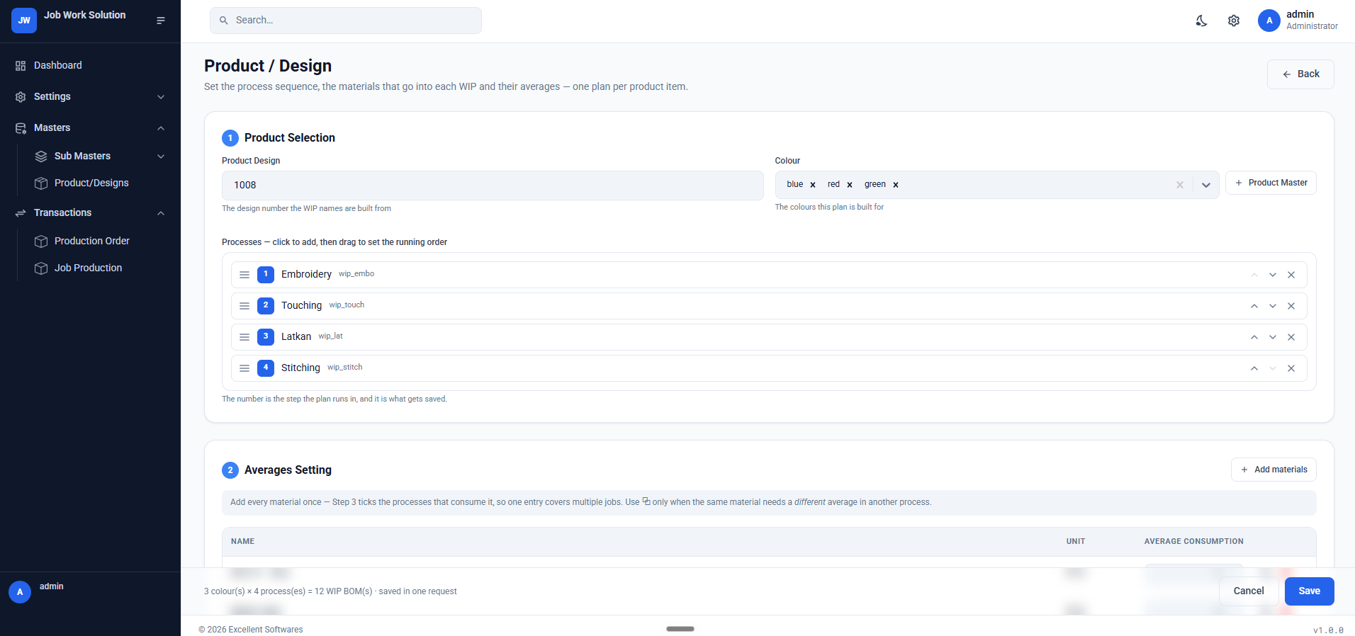
      - 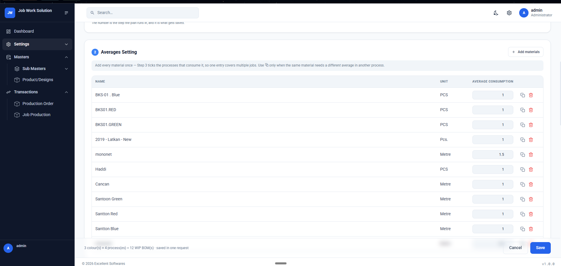
      - 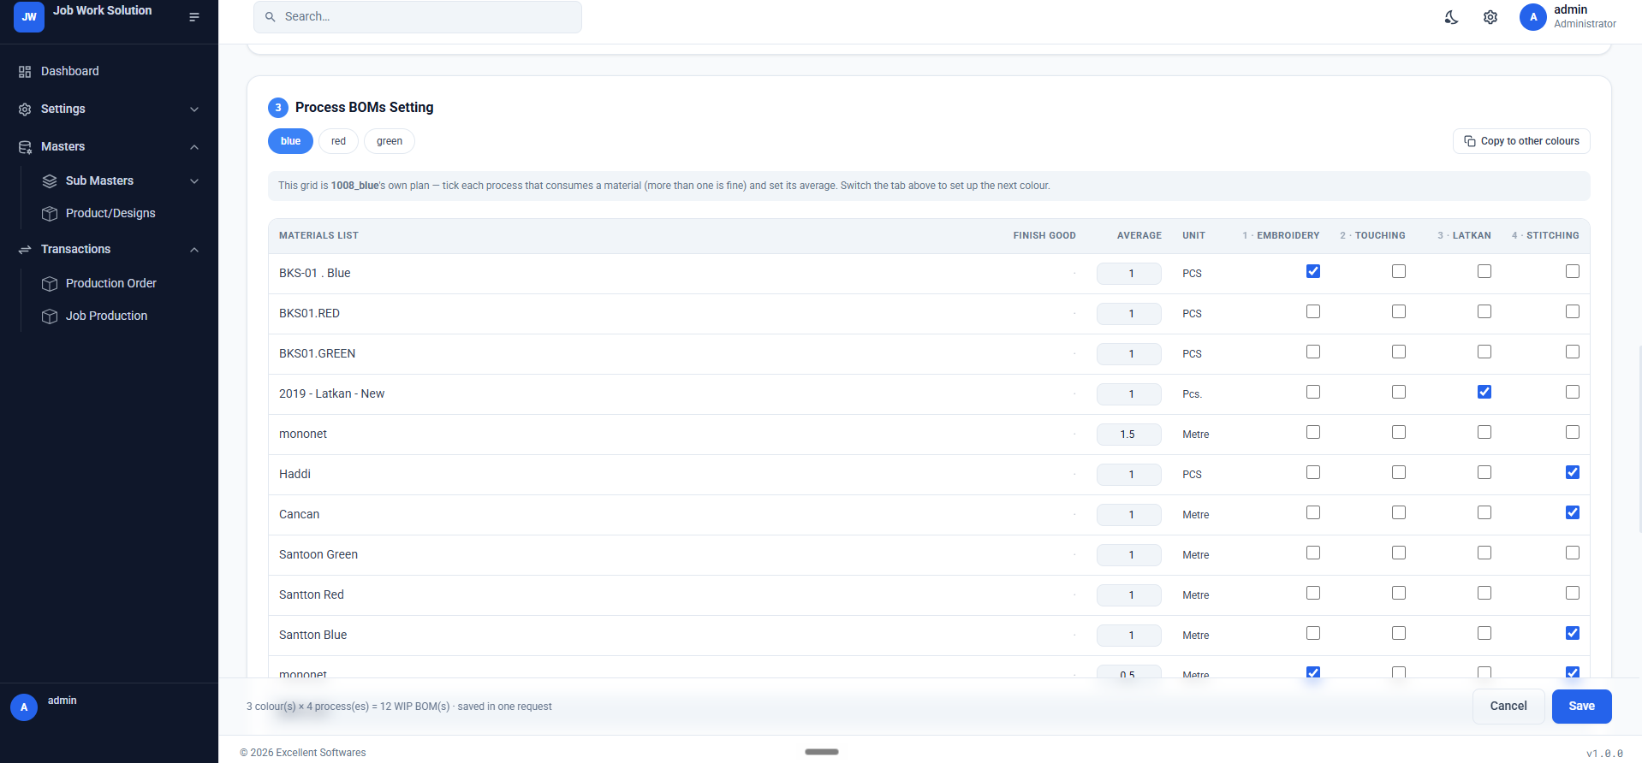
      - 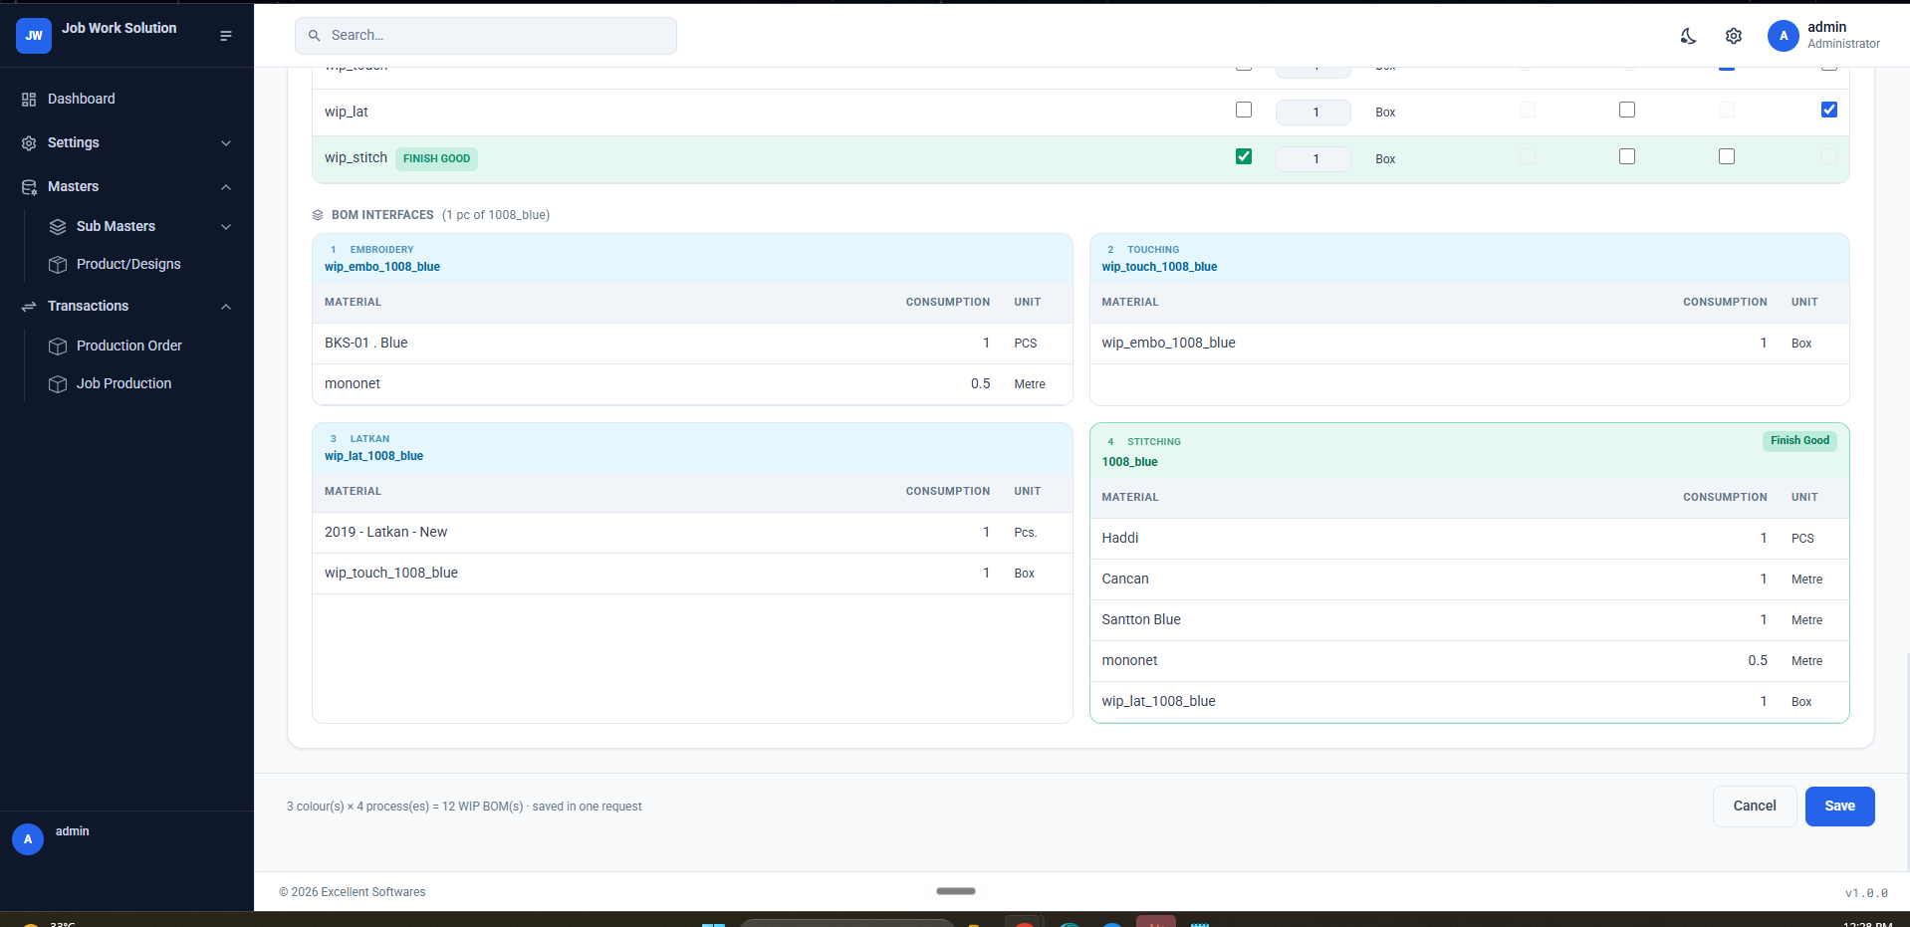
    - Production Lifecycle (per product) - with issue/receive options connecting to Karigars and issue/receive voucher prints
      - Main Window: Lets user select a product and view all its production orders from dropdown, Shows per production order’s lifecycle in detail. processes set in material-and-process-setting are shown here for that product with issue pending quantities calculated according to the production order qty specific to each color. A process/job gets activated only when a karigar has been assigned to it (along with job rate per pc, and 3 production due dates to receive from him in tranches - default pcs to receive in tranches are 30%+30%+40% - but there should be options to select different ratios, and a date selector for each due date), and before that, that process should be visible and ready with its qties, but locked. The main screen purpose/options is to
        - View/Start a Job: Assign karigar to a job
        - Each job card has their bom’s line items per color for that production order, total issue quantities, balances, receive balances etc. Refer to Busy Wireframe Sheet for total info required be job card.
        - Issue or Receive Material lines in each job simply (with a sticker of size 3*4 inches printed for info on each issue or receive line items with their post - pending balances)
        - In-Stock Material/WIP per job that are issue-ready, and Out-of-Stock Material/WIP to issue per job that are holding the job and delaying.
    - Job Cards View - project mgt style with sample/product/material image set primary for that job - default is product or sample image) (including Active, Delayed, Finished tabs)(each job is shown as a card with image and info bottom bar.)
      - Main Window: Jobs Cards view in a project management style card view with
        - sections/tabs for delayed, upcoming, stuck (due to out of stock materials or wips), priority productions, restock productions etc.
        - Filters and sort options for cards at job-detail level, and on the card.
        - ⅔ size of the card is image and the rest is info bands on top (job no and product and karigar name - quick info) and bottom (job status/progress, dates and due dates etc.).
      - Right Pane: With lifecycle view of that product or production order opening on the side as a right pane and showing status by color indications.
      - Design References:
        - 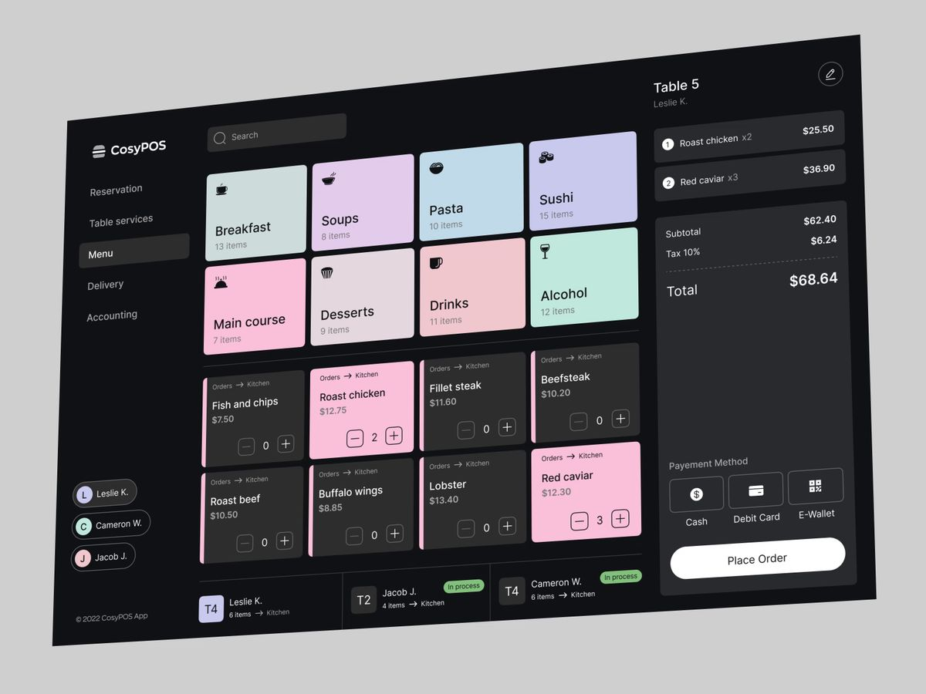
        - 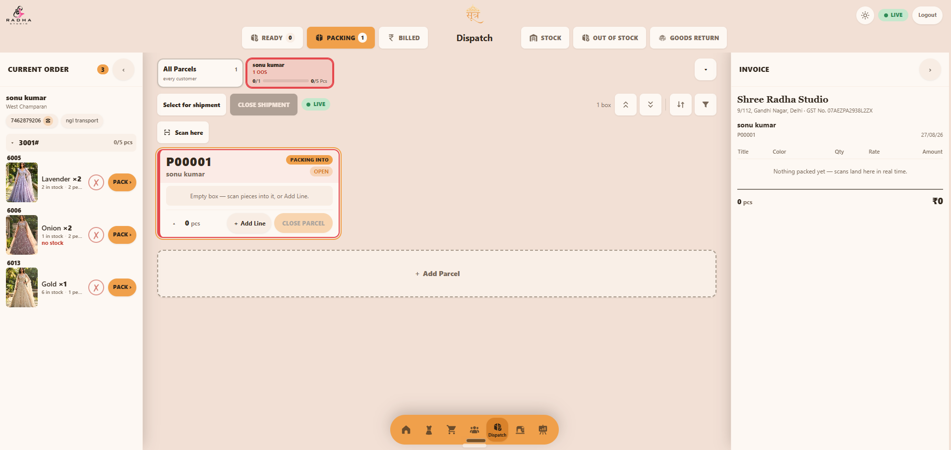
    - Costing - this is the cost setting/approving module where costs per product or sample in production being accumulated and shown for completed productions(primarily used), incomplete productions and past productions (as different tabs). For each product, rates of all materials consumed per pc are picked and added, the job rates for all processes per pc are added and shown, and a gross profit margin is added (40% by default but settable/customizable by categories for future calculations)
      - Main Window: Shows sections of all productions (completed incompleted etc), and products not priced yet, in a cards view with relevant meta info- and on selecting any production or job card, the right pane opens the full breakdown, with a recommended price. This price is then editable before setting and adding it to product master and sync the change with busy.
      - Right Pane: Shows cost breakdown and gives a field to enter own price for that product master.
    - Karigars, Analytics and Reports: Shows each karigar’s production orders, their status, total pcs ordered vs total pcs recd, category (by job process he owns) etc. Give relevant analytics and reports for karigars here with simple graphs and visual analytical tools.

- Dispatch:

Used by dispatch desk operator, packer (phone), floor supervisor, accounts.
1. Description:
Dispatch is the floor's live order-queue board: it decides what goes out today, packs it piece by piece against a barcode scan, cuts the invoice, groups parcels onto a vehicle, and books what comes back. Desktop-first (the desk runs a 24″ screen) with a phone companion for scanning on the floor. One sticky top bar: firm logo, wordmark, dark-mode toggle, LIVE/OFFLINE realtime chip, logout. Six nodes — READY, PACKING, BILLED | STOCK, OUT OF STOCK, SALE RETURN — each with a live count badge. Mobile collapses to a tab scroller and opens on Pending Orders. Every node is deep-linkable.
1.1 Sub Menus
1.1.1 Ready Orders
The “what can I pack right now” board. Only customers with at least one in-stock line appear; anything fully short belongs to Pending and Out of Stock.
Left Pane
– Queue rail a persistent rail carrying the board's sort (default: due days, oldest first) and its filters — due days left, created before, in-stock only, tier, priority, total pcs — with the active set visible as removable chips and a live count of orders and pcs. State persists in the URL.
Main Window
– Card grid one card per customer (1–4 columns by width), outlined with a priority ring in the colour of that customer's most urgent order (P1 red → P5 grey).
– Card head customer name, tier chip, market · city, and tap-to-call chips for the customer, transport agency and broker.
– Per order order no, created date, due-days pill (red at ≤ 2 days), an amber “n/m pcs in stock” tag when partial, priority disc, optional note strip.
– Per line photo thumb, design no, colour dot, × qty, stock tick. No rate and no amount on this board — the floor must not see money.
– Footer total pcs with packable count, and a large PACK ▸ button; the whole card is the same target. A fully covered customer hows a green “Fully planned” pill instead.
– PACK ▸ moves the whole customer into Packing, flips their approved orders to PACKING, auto-opens one empty parcel and jumps to the Packing node with that parcel selected.
– Controls search by customer or design no; collapse-all and expand-all for dense days.
Right Pane
– Pending Orders the pane in 1.1.2, docked under the top bar, drag-resizable, open by default on wide screens and collapsible to a rail. Read-only reference while the operator works.
1.1.2 All Pending Orders
– Scope the full approved order book — the Ready right pane on desktop, the default full-screen node on the phone: every approved order, in stock or not, grouped by customer, refreshed in realtime. A failed refresh keeps the last good list behind an inline notice.
– Three levels customer chip (name, N orders · P pcs, due-days pill) → expanded customer (tier, market · city, call chips, total pcs and ₹) → order row (order no, date, red “n short” badge, priority disc) → expanded order (qty × ₹rate = ₹amount, plus “n of this design is at the last production step” against every short line).
– Controls search, sort and filter on the same axes as Ready — this list carries the whole book and must be navigable without scrolling.
– Money rates and amounts appear here and on the packing desk only.
– Actions none. Approval happens upstream; this screen informs, it does not decide.
1.1.3 Packing Terminal
The packing desk console. A chips row across the top is the master selector — one chip per customer (name, shortfall, invoiced/floor parcels, progress bar, packed/ordered pcs) plus an All Parcels chip, scoping all three zones.
Left Pane — Current Order
– Shows the customer's whole live order book, collapsible by order no → design no → colour line, so the packer sees everything owed before closing a box.
– Per line photo, colour × qty, “N in stock · M pending”, a ✗ / n⁄m / ✓ progress disc, and a PACK › button that adds one piece to the open box for items that cannot be scanned.
Main Window — Parcel Boxes
– Board parcel cards, each with a customer-colour bar, short code (AA01), status pill OPEN / PACKED / INVOICED, and a PACKING INTO tag on the active box.
– Scanning a Scan-here toggle claims the desk for the Bluetooth scanner, arbitrated so phone and desk cannot double-fire. Every scan is validated server-side: accepted, accepted-with-warning, or rejected loudly — duplicate, not in this order, line full, parcel closed, unknown serial. Warnings surface identically on desk and phone.
– Per box lines with photo, design · colour × packed/planned, qty stepper and remove, both behind a confirm that warns the pieces become scannable elsewhere; + Add Line; CLOSE PARCEL. + Add Parcel below the board.
– Controls collapse/expand all, sort, filter by open / packed-awaiting-invoice / invoiced-awaiting-shipment, and a select-for-shipment mode with a floating “N parcels · M pcs → Create shipment” bar.
– Phone companion picker → scan → review → invoiced, with a large tally, green flash on accept, wake lock, and a CLOSE PARCEL that hands the box back to the desk for review.
Right Pane — Live Invoice
– LIVE a real letterhead invoice building itself as pieces are scanned — Title | Colour | Qty | Rate | Amount, pcs and ₹ total.
– REVIEW triggered by CLOSE PARCEL: “fix qty and rate, then confirm — nothing reaches accounts until you do.” Qty and rate are editable and the bill-to party (gaddi / branch ledger) is chosen here. Confirm cuts the invoice and flags it for print.
– Tax the invoice carries a GST block — taxable value, CGST/SGST or IGST by place of supply, rounding, grand total and amount in words — on screen and on the A4.
– DONE invoice no, totals, confirmation, Print A4. The box stays on the board greyed as “awaiting shipment” until grouped.
– Shipment CLOSE SHIPMENT opens a sheet — consignee selector, pre-ticked list of invoiced-unshipped parcels, optional note — and issues a transport document. Unticked parcels stay for the next trip.
1.1.4 Billed
– Sale Invoices invoiced orders grouped by customer — order no, created on, delivered on, delivered-in-days, every line (design · colour · qty × rate = amount), with order and customer totals.
– Shipments History one row per shipment — shipment no, date, consignee, transport and broker, parcels, pcs, invoice numbers carried — expandable to the parcel list and re-printable as the transport document.
– Filters date range (defaults to today), customer tier and transport, URL-persisted and shareable.
– Per order an invoice view with customer score, last broker, last purchase, voucher no and totals; a Return shortcut into Sale Return; re-print of the A4.
– Print A4 sale invoice — letterhead, bill-to vs goods-for split, lines, GST block, amount in words — and a separate transport document per shipment.
1.1.5 Out of Stock
– Two row kinds everything the floor must source, owed or about to be. ORDER — ordered and out of free stock; and RESTOCK — high demand, low cover, no order yet, drawn from the nightly demand-scoring engine.
– Restock rule a design qualifies when it is selling (velocity > 0), its days-of-cover is below the configured production lead time, and it is not already flagged for priority sale. Cards read “selling 4/day · 22 days cover · 18 free · score 61”. Thresholds live in config and tune without a deploy.
– Counts strip pcs to produce, sourceable now, in production but not at the last step, and nothing in production — the last in red, linking to Production.
– Per design photo, colour matrix — pcs needed, at last step, in order, received, six due dates — with red “Nil” cells, karigar pills with score and call button, and a link to the product page.
– Controls sourceable-now vs everything-short toggle, restock suggestions on/off, three sorts, karigar filter.
1.1.6 Warehouse Stock
– Three tabs Finished Goods, Material and Work in Progress, sharing layout, search and filters.
– Finished Goods one row per design + colour (SKU), reading that colour's own free stock and in-production rather than the design rollup: photo, design no linking to catalogue, colour, FG stock, in production, status pill OUT OF STOCK / LOW / OK.
– Material one row per material + shade with stock on hand, on order, consumed this month, reorder level and supplier.
– Work in Progress pcs by design and colour sitting at each production step, with the karigar holding them and days at that step.
– Controls search, sorts (scarcity first by default), filters for low only, out only, in production only. Stat tiles summarise the whole filtered set, not the visible page — the board must page or virtualise the full catalogue without truncating totals.
1.1.7 Sale Return
A four-step desk wizard — Customer → Pieces → Preview → Credit note — with the step rail always visible, so the man at the counter leaves with a document.
– 1 Customer pick the customer, enter parcels accepted (the first thing the desk counts), then multi-select the dispatched or invoiced orders being credited against.
– 2 Pieces scan the barcode to resolve design + colour at the order's price, or search a design and tap a colour chip. Repeat scans bump the line; qty is editable, zero removes.
– 3 Preview design · colour · qty · rate · amount with totals and an optional note. Anything blocking submission is listed in words, not just a disabled button.
– 4 Credit note issues a numbered credit note in the same transaction as the return, prints it, and lists recent notes as the desk's audit trail.
– Stock rule the credit note is issued immediately, but pieces re-enter finished goods only when the return clears accounts approval; the note carries a “stock on approval” badge so nobody assumes otherwise.
1.2 Cross-cutting rules
– Money visibility rates and amounts appear only on the pending pane, the packing desk and Billed. Never on the Ready board or the phone.
– Realtime every board is push-updated; a poll fallback and a LIVE/OFFLINE chip mean the floor knows whether it is looking at live data.
– Server authority stock, scan validation, pricing and totals are decided server-side; the client renders optimistically but never invents a number.
– Roles packers see the floor and no money; the desk invoices; accounts approve returns and credit notes.
– Audit every parcel, scan, invoice, shipment and credit note traces to a user, a timestamp and a document number.

- Hub - Master Views, Book Views and Reporting Module (all reports and masters include pictures where relevant) -
  - Sub Menus:
    - Masters: All masters have tier 2 and tier 3 screens where all relevant information about that master, collected throughout the erp, should be visible in lists, grids or graphs wherever relevant.
      - Items:
        - Products
        - Material
        - WIP
      - Ledgers:
        - Customers
        - Suppliers
        - Direct Purchase Vendors/Jobbers (Designs are purchased in whole as pcs for trading - no need for production - we might “sell”/invoice our materials to these accounts in order to receive the readymade pieces directly at inward) (these orders are to be shown in Production Orders but have to be noted in a seperate “Direct” book)
        - Jobbers (Karigars)
        - Brokers - (Agency and Brokers within Agency as diff tabs)
        - Transporters
        - Miscellaneous

    - Reports: (Notes) All Report Sub Menus should have an excel sheets grid with all columns mentioned below, with filter, sorting options at each column head; and a column chooser that hides/reveals columns, on the same size white sheet background card. In column chooser, give ability to make pre-defined views with selected columns and selected filters and sorts on screen, per report per user, and let the admin have the option to set a pre-defined view as default for any/all user roles. Also let the user make custom reports and give full working tools to customize and visualize reports.
      - Purchase (and Purchase Return)- Reporting of all books in purchase with following columns and other relevant ones you think are important:
        - Purchase Order: Pick relevant columns from below
        - Purchase Inward: Date|Particulars(Supplier Name)|Material Item Name|Material Item Group|Item Color|Item Barcode|Supplier|Supplier Address|Vendor Broker Agency | Vendor Broker | Consignee|Consignee Address|Voucher Type|Voucher No.|Supplier Invoice No.|Supplier Invoice Date|GSTIN/UIN|Narration|Order No. & Date|Terms of Payment|Quantity|Rate|Value|Addl. Cost|Gross Total|PURCHASE|IGST INPUT|FREIGHT INWARD UNDER GST|ROUND OFF|CGST INPUT|SGST INPUT|JOB WORK (GST)|JOB WORK (RCM)|Discount on Purchase with GST
        - Purchase Return: Date|Particulars|Buyer|Buyer Address|Consignee|Consignee Address|Voucher Type|Voucher No.|Ref. No.|GSTIN/UIN|PAN No.|CST No.|Narration|Delivery Note No. & Date|Despatch Doc. No|Despatch Through|Destination|Shipping / Bill of Entry No.|Shipping / Bill of Entry Date|Quantity|Rate|Value|Gross Total|Sale|IGST OUTPUT|ROUND OFF|CGST OUTPUT|SGST OUTPUT|DISCOUNT ON SALE WITH GST|Freight Outward Under Gst|Freight On Sale|Item|IRN|Ack No.|Ack Date|E inv Y/N|Sale Type
      - Sale (and Sale Return):
        - Sale Orders - Pre-set filters with hard buttons for All / Approved and Pending / Invoiced
        - Sale Return -
      - Product Compare Hub:
      - Production:
        - Production Lifecycle and Issue/Receives
          - Issues
          - Receives
          - WIPs
          - Jobs:
            - Ongoing
            - All (with filters of “Finished”)
        - Production Orders and status
        - Samples (“in-designing” and “deployed-but-no-production-order-or-stock-yet”
        - Karigar Analytics
          - Karigar Material/WIP Balances
          - Karigar-wise Job Orders and Issue/Receive Satus
          - Karigar Analytics - Speed, reliability (receive vs due dates), capacity, costing vs sale, etc
        - Production Floor Analytics: Userwise production activity (like number of issues made in a day by production
      - Dispatch:
        - Pending Orders
        - Invoiced and Shipped
        - Warehouse Stock - Product, Material, WIP
        - Movement Metrics (seperately for finished goods warehouse, and material warehouse)
      - Commissions:
        - Broker Agency Commission Calculations and Payments
        - Broker Boys Commission Calculation and Payment
      - Payments:
        - Sale Invoice Pending Payments (with overdue filter) customerwise and sale orders wise
        - Payments to Brokers
        - Overdue Metrics and Customer Level follow up info

- Studio -

- Sub Menus:
  - Image upload and Management center - with diff image upload button sets for diff categories of product - like blouse and saree for saree and lehenga and all side profiles for lehnga, etc.;; bulk management options etc);
  - AI Photoshoots Center - convert any existing product’s uploaded image to model photoshoot or ai video, using all embedded pictures and video of that product as context in one click;
  - AI Designer [Codename “Stitch” - chatbot agent with design skills, pre-trained on our categories, and with editable/tunable design pane on the side like lovable or claude design) [that lets user upload their context as input - prompt or pinterest or insta links - lets user choose an existing product/wip/material image or multiple as context from a pop up grid with filters and sorts options (with actual sale and consumption data sent as metadata in the context to reflect success of a design - give an option to turn off metadata) - is an agent with its own tracks/history/memory, design formats, RL’ed on taste, and skills - and outputs in specific formats using seperate sub-skills - when clicked on these format quick-buttons - like hand drawing of a design, or a grid of design inspire options based on prompt of refernce links. This will run an api model calls like nano banana or gpt image 2 in specific pre-defined workflows in the beginning - optimized for catching indian ethnic bridal lehenga level intricate embroideries and stones and shines, and color grading and lighting and making hyper-realistic like real world models with real world pictures and videos), and will be taken to agent in cloud mode later for using higher better models and other tools and connector calls like higgsfield in our workflow). Give a module within this designer module to tune the agent and adjust the workflow (give options like setting prompts, loops, etc whatever you deem fit) and set the api’s and track usage etc. that opens as a side pane from right of the screen with a translucent type background, more like an agent settings panel with organized tabs of its own. Some notes on the designer hub and agent stitch:
    - - Design inspiration and templates according to product categories.
    - - Button to create a material design into any or all category of inspirations
    - - Moodboard as a common ground for designer agent and chachu (user) where regular context can be uploaded via whatsapp share or something - and used at any place within the agent (like canva image uploads).
    - - Replenishing and Auto-Scrapipng from moodboard

    - References of Inputs needed:
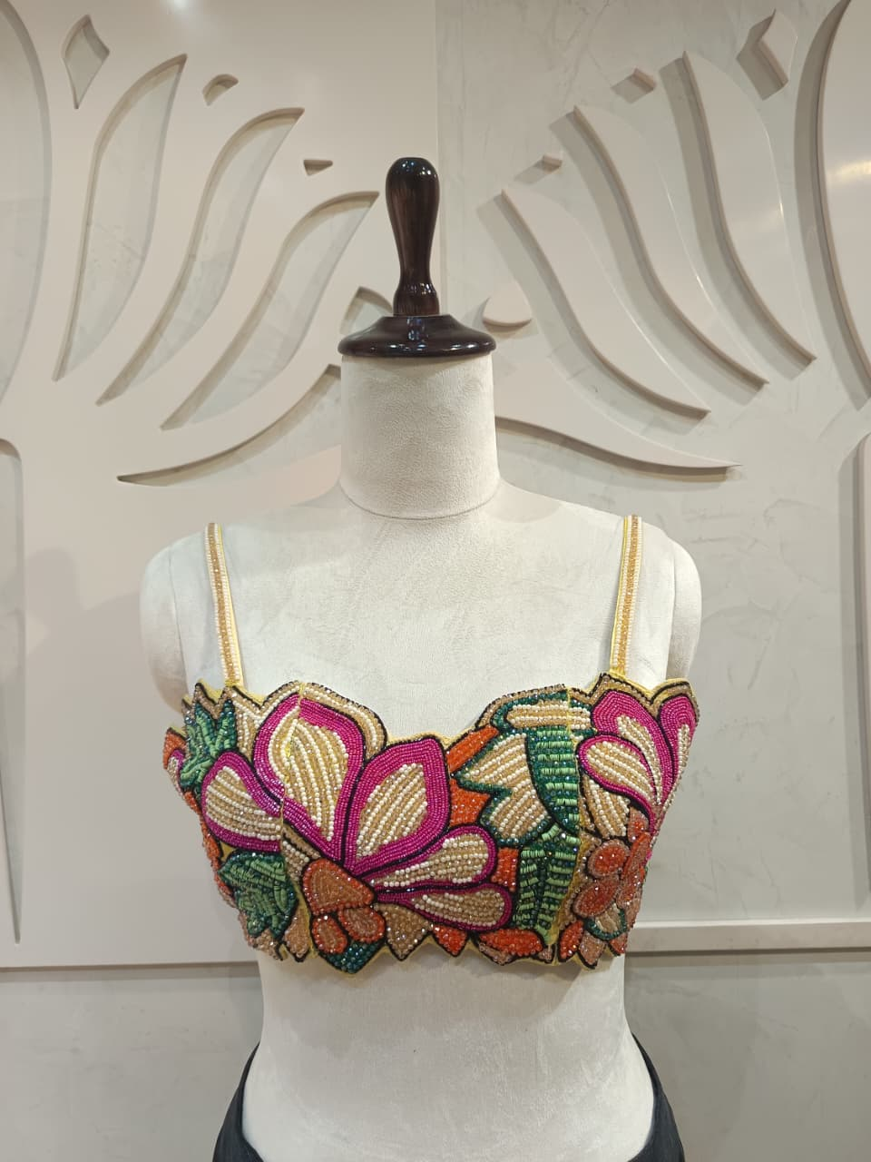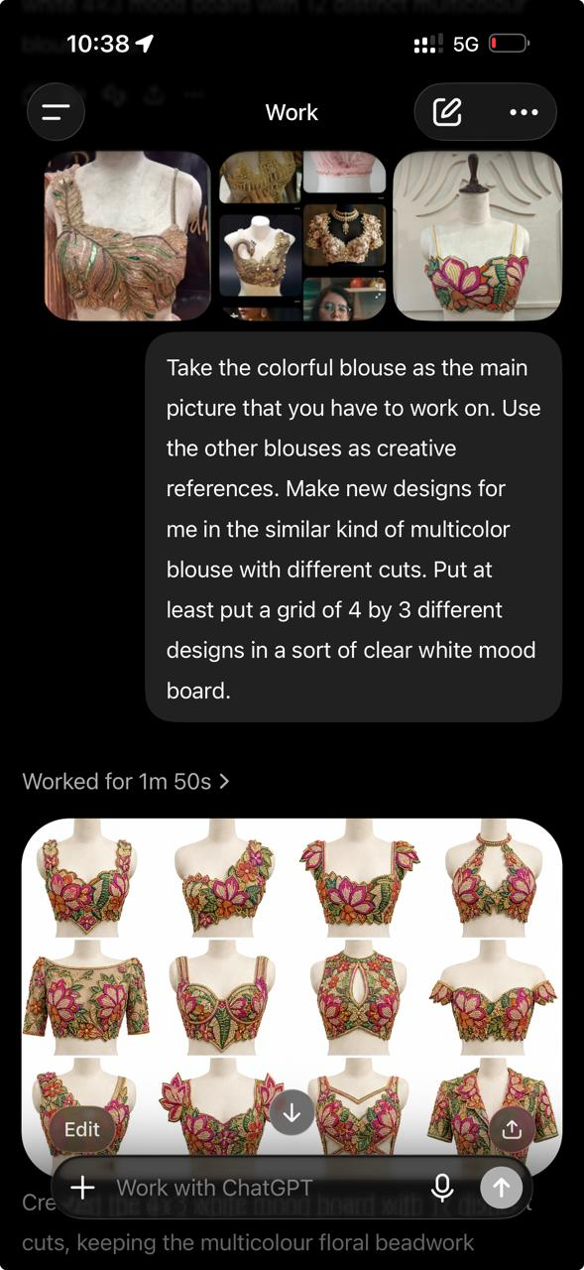

    - References of outputs needed (editable and re-promptable)
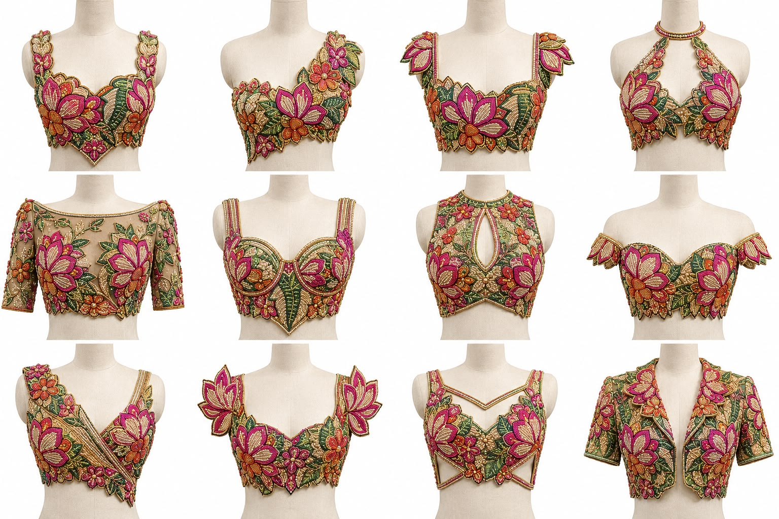
    - References of Pre-Defined Output Templates (Will need to upload more template references in the agent tuner window pane):
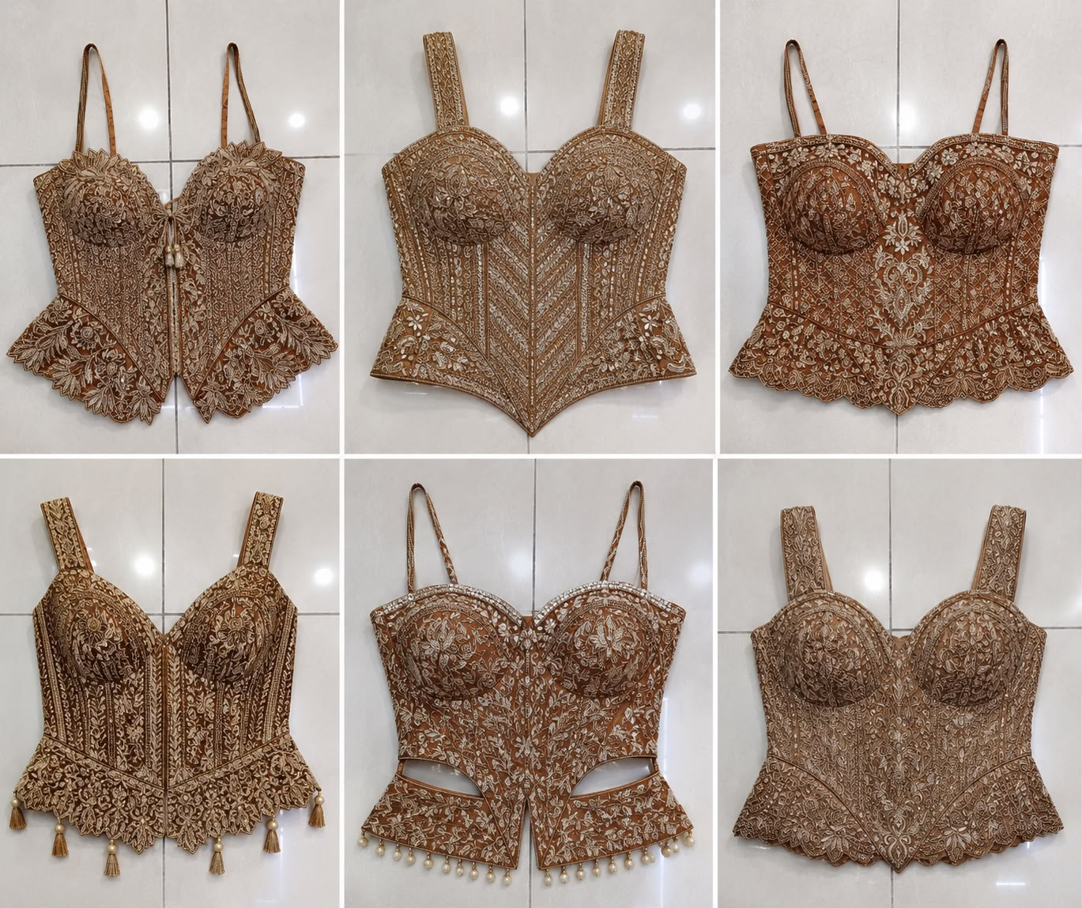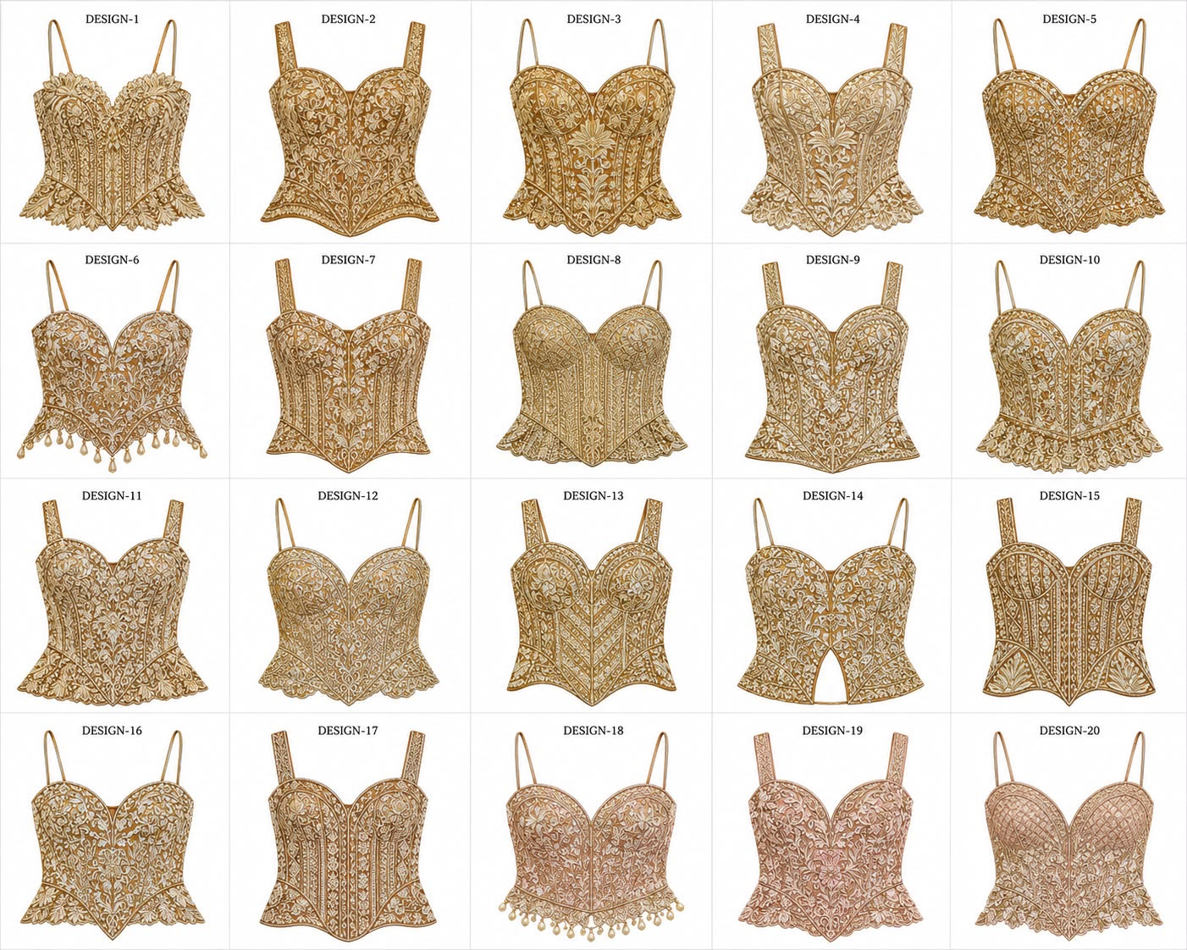



    - Design and Screen References for the AI Designer (“Stitch”) / Product/Material/wip Selector / and Editor Mode:

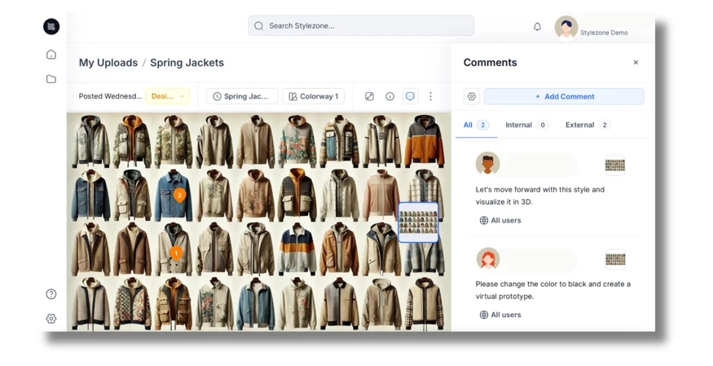
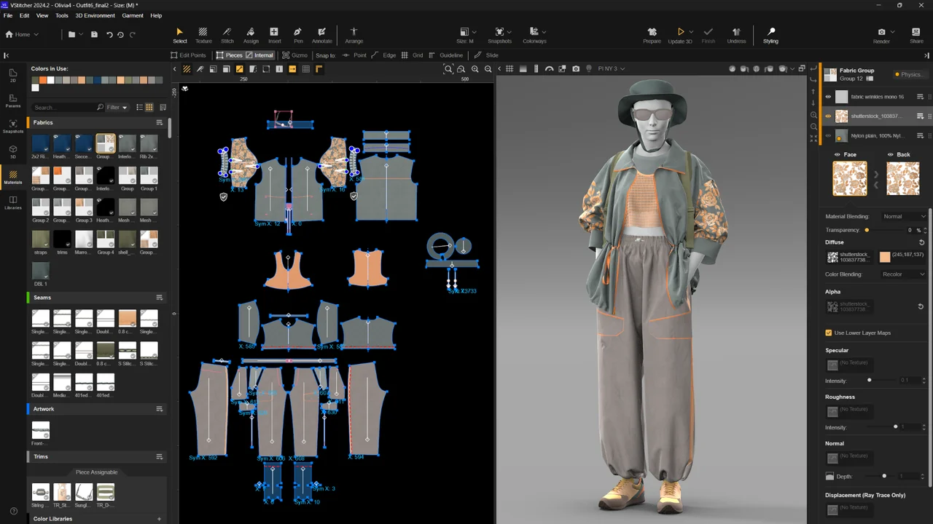

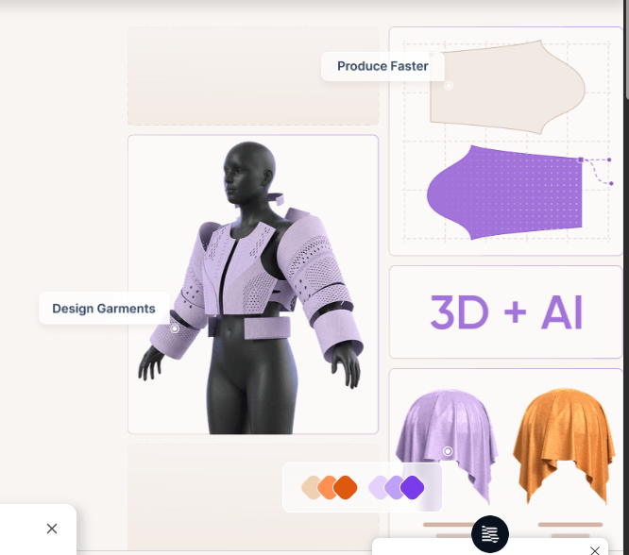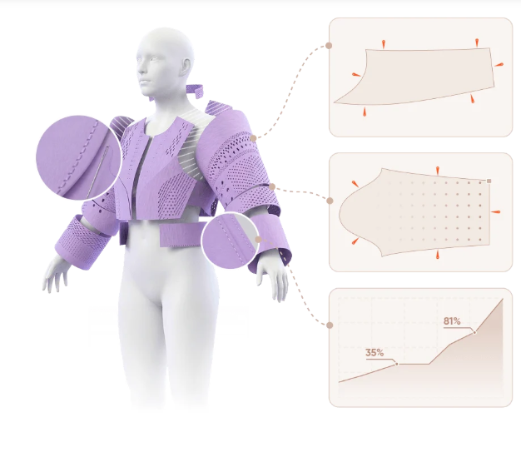


- Channels - Lets User connect their Main Business to other businesses or firms on our platform (like Shree Radha Studio to Radhika Sarees or vice versa) and lets them transfer and/or view selected product, sale, dispatch or production level data to the other firm as data packet or one time permissions. This view also shows transfer history and currently active permissions. (In the example of SRS and Radhika Sarees, they are both seperate firms but partner in operations - one makes the supply for other in some cases - so i need to be able to send for production order in SRS, marked with “Send to Radhika”, and the receive should show inbound at radhika’s terminal, and the activity should show in this view). Same for a D2c or an internation channel when they exist, where firm is diff but operations/info/stock are co-ventured/shared/reserved.

## Bottom Bar (within side pane) : Light mode/Dark Mode button, Userprofile picture with floating menu open to user options - profile, show/hide modules, track etc

#Design References for Some Screens:
- Side tab (main menu) for desktop webapp view (with appear and collapsible on the side sub menus) (This stays at the bottom on mobile in the bottom module menubar) - A sleek tab with icons and module names with hover over and view sub menus.

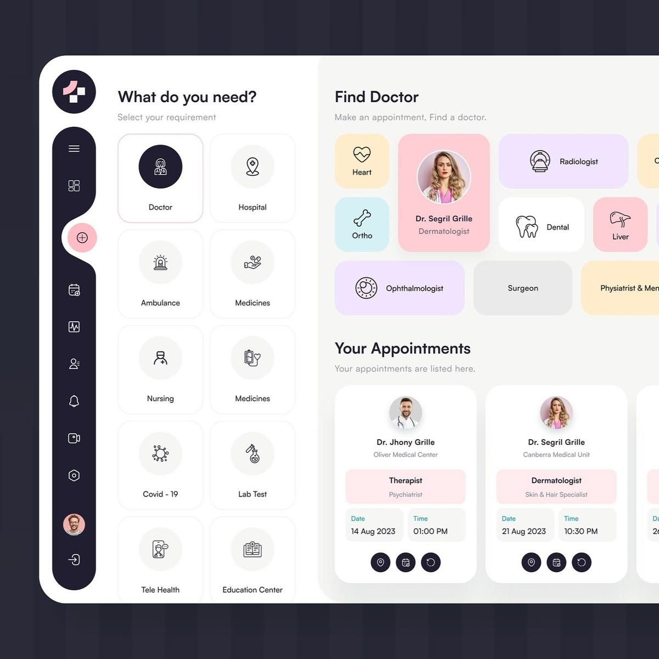

- Production Jobs Cards View and Dispatch Ready Order Cards and Packing Cards View reference:

  - Production Job Card View Right Side pane : Lifecycle view of the production order that the job belongs to with lifecycle and each job (with status colors) presented as timline with a view like this of all prodcution processes set in that production order for that product, and a common view of relevant fields for all processes that are present in the Busy Wireframe Sheet:

